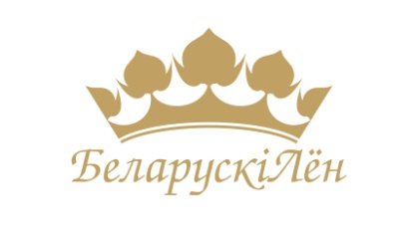
COMMERCIAL OFFER

Dear Ladies and Gentlemen,

Orsha Linen Mill is the leader of light and textile industry in the Republic of Belarus. Our enterprise is the largest in Europe and one of the biggest producers of linen fabric and products in the world.
Orsha Linen Mill has been putting into practice the whole manufacturing cycle from processing of flax fiber to production of finished fabric and sewing goods under the registered trademark Orsha Linen Mill since 1930.
Our enterprise offers a large variety of linen products:
- apparel fabrics;
- fabrics for bed linen;
- fabrics for table linen;
- decorative and upholstery fabrics;
- fabrics for technical purposes;
- linen yarns (of dry and pneumatic-mechanical spinning);
- cottonized linen fiber.
Besides, Orsha Linen Mill accomplishes the sewing process of ready-made products:
- table linen;
- bed linen;
- kitchen linen sets;
- plaids, bed covers;
- sets for sauna;
- towels and sets of towels.
Orsha Linen Mill possesses the International quality management Certificate STB ISO 9001-2009. All our bleached, acidified linen, half linen (blend with cotton) fabrics comply with the criteria of Oeko-Tex Standard 100.
During the years of 2012 – 2014 Orsha Linen Mill accomplished the first stage of modernization process, while the years of 2015-2017 are marked with the second stage of modernization so that our enterprise has increased production facilities and enhanced the quality of produced products. Currently Orsha Linen Mill possesses the latest equipment from the world-known manufactures such as «Picanol», «Carl Schmale Durate» and «Golden Eagle».

Due to the favorable geographical location Orsha Linen Mill accomplishes direct supplies to different parts of the world within the shortest possible period of time. We offer a range of wholesale and retail tailored orders, along with ready-made products for hotels and catering companies to suit the most demanding requirements and quality standards. All supplies are held on terms of the FCA Orsha basis according to INCOTERMS – 2010, 100% prepayment, and direct contracts.
Discover new business opportunities by working with Orsha Linen Mill.

Contacts:
3-Molodezhnaya Str., Orsha, 211382, Republic of Belarus

Chief of Export Department
Andrei Shaviro
Tel.: (+375216) 531651/5069 77
Fax: (+375216) 53 01 77
e-mail: linenexport@mail.ru
linenexport@tut.by
Website: linenmill.by

